# Intro

The main question that will be answered by the end of this presentation through multiple research questions would be, is there a linear relationship between population and renting in Ontario in the last 30 years? The topics that are discussed are birth rate, economic indicators, immigration, and family structure. The research questions proposed are:

How does birth rate affect the increase/decrease in renting homes? How has income and rent changed over the past 30 years? How has immigration affected renting factors? Who is renting and does divorce impact renting in Canada?

# Birth Rate

One of the first areas we wanted to look at was “Birth rate”. This ended up being a bit of a dead end as any of our comparisons didn’t seem to draw any direct conclusions. However, it does suggest that as renting prices go up and space becomes more limited. The Birth rate is more likely to continue its downward trajectory. One of the biggest costs to having children is housing. As of 2011 the homeownership rate is beginning to decline. Therefore increasing the dependency on renting.

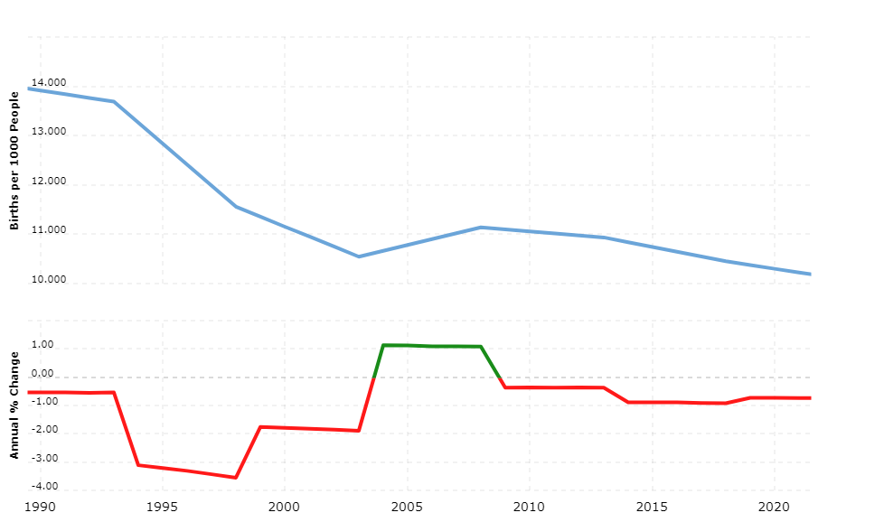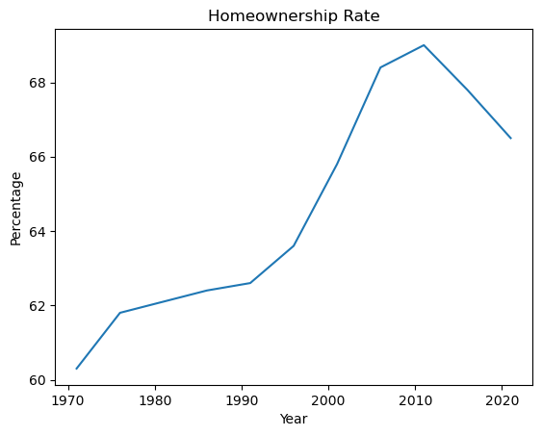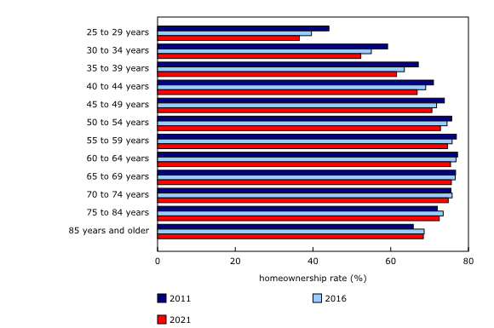

# Immigration

# Financials

Examining the relationship between rent prices and population, we should look at the population's buying power of the population and the change in rent overtime. We see that the average household income has been steadily increasing along with the average price of rent, clearly a positive linear relationship

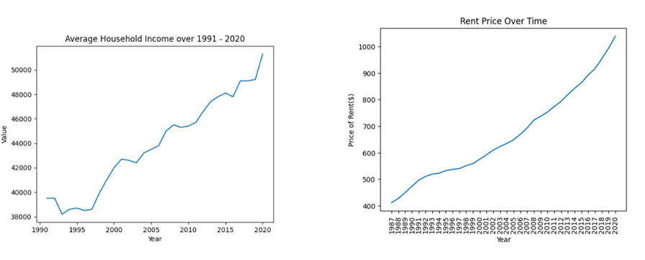.

However, there is more to consider, particularly in the context of home ownership. The prices of homes have been increasing at an exponential rate, in just the past 10 years. Going from $379k in 2011 to $739k in 2021 (Statista 2021). By Contrast Income has only increased nominally by around 10k, going from ~$40k to ~50k. Home ownership has become a lot more expensive compared to Renting.

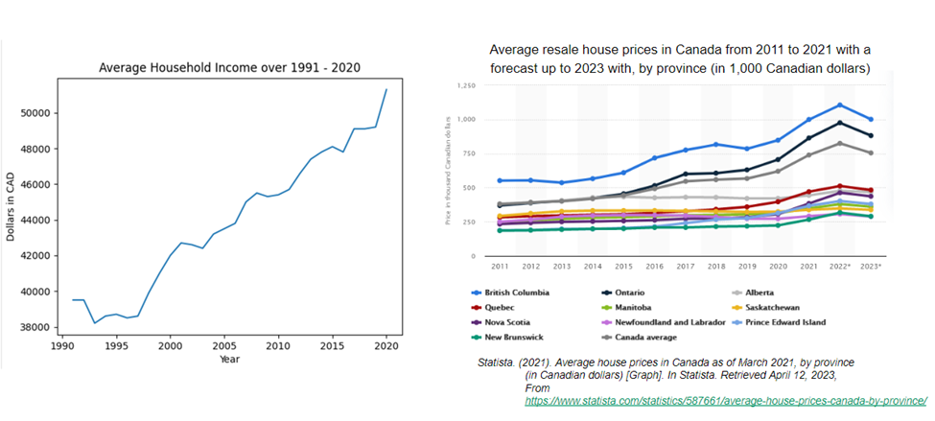

Additionally, there is a steady proportional rise in the price of rental unit types, whereas there seems to be a substantial decrease in homeownership among younger adults. This can be seen as a reaction to the rising cost of home ownership and the comparably reasonable pricing of renting.

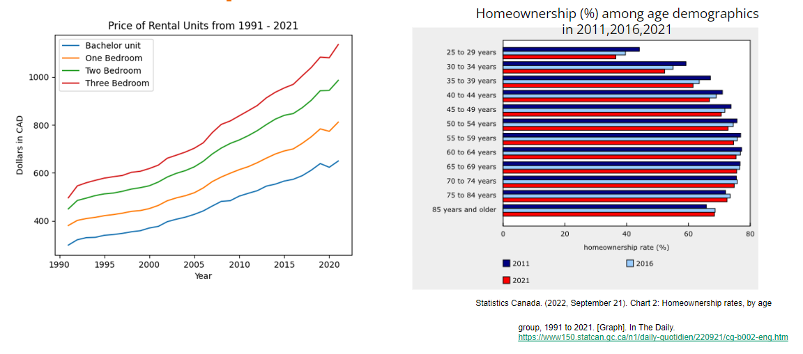

# 

# Family Structure

According to the data, 1987 had the most divorces with 78, 870, and 1970 had the least number of divorces. The number of dual earning families is increasing far above the number of single earner families.

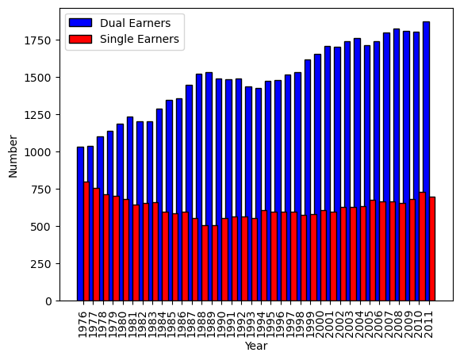

In general it does cost more to have children as well in a family, as the average income increases, the more children are had.

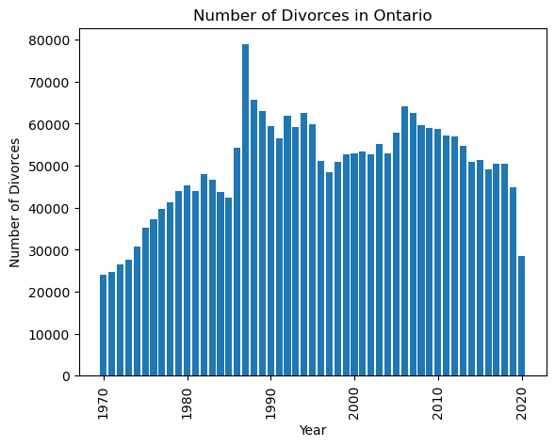

Does this play a part in renting?

Using speculation, we could assume that if it costs more to maintain a family with more than one child, and the average income of families is rising, there would be more desire to rent; this would be if the cost to rent is less than the cost to purchase a home. If the number of divorces continues to climb, and single earners do not earn as much as a dual earning-family, there could be a projection for more people to begin renting.

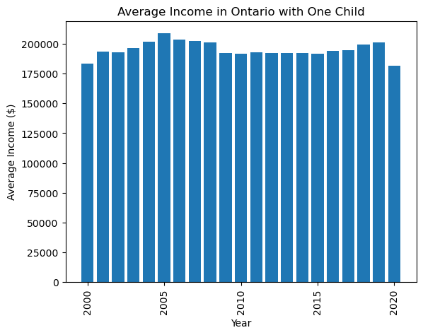

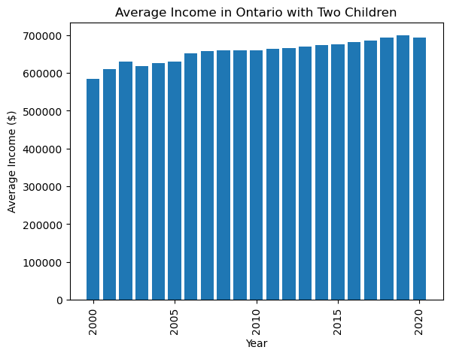

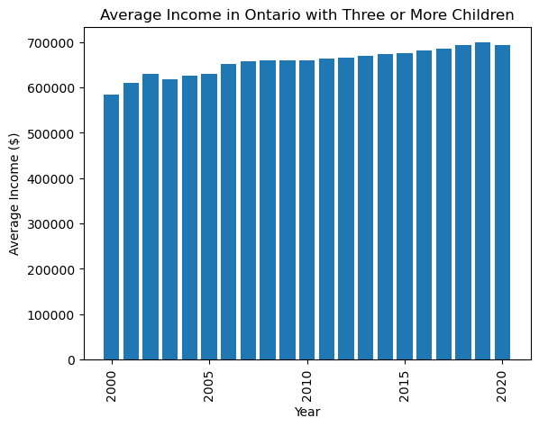

As far as the data goes, there is no real evidence to show that divorces have an impact on renting, but there is a possibility if the number of divorces continues to climb, more people will rent.

# Summary of Findings

Birth Rates have been declining and home ownership has been decreasing, as a result there's an increasing dependency on renting. Overall household income has been increasing, along with renting. However in the context of housing, the cost of ownership has been exponentially rising making renting the more feasible option. Despite declining birth rates the population has been increasing at a stable rate.

-Enter Ankit

# Citations

Statistics Canada. (2022). Table 11-10-0012-01 Population estimates on July 1st, by age and

Sex. Retrieved April 3, 2023, from

<https://www150.statcan.gc.ca/t1/tbl1/en/tv.action?pid=1110001201>

Statistics Canada. (2021). Residential property price index (RPPI), property type: rental apartments,

Canada, monthly (1146388B). Open Government Portal of Canada.<https://open.canada.ca/data/en/dataset/1146388b-a150-4e70-98ec-eb40cb9083c8>

Statista. (2021). Average house prices in Canada as of March 2021, by province (in Canadian

dollars) [Graph]. In Statista. Retrieved April 12, 2023, From

<https://www.statista.com/statistics/587661/average-house-prices-canada-by-province/>

Statistics Canada. (2022, September 21). Chart 2: Homeownership rates, by age group, 1991 to 2021.

[Graph]. In The Daily.<https://www150.statcan.gc.ca/n1/daily-quotidien/220921/cg-b002-eng.htm>